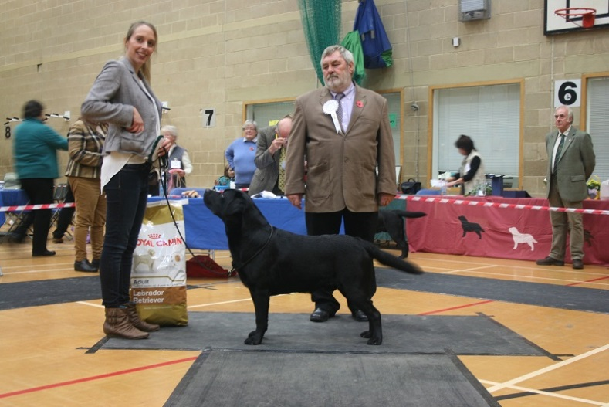Best Dog & Reserve Best In Show - Miss H Braimbridge -Southridge Sky Rocket to Hanabee

MINOR PUPPY DOG
- Glen MILLROSEGLEN MAKE MY DAY
- Van Leeuwen LINJOR CASSABLANCA
- Pastusiak SECRET WAY TO MY HEART OF LABGOLD
- Allen TIMOURON TIME WILL TELL
- Felton-Page MARSHWIGGLE MR CARSON

PUPPY DOG
- Powell SEATALLAN XERULA
- Harvey-Major LINJOR CHOPIN JW
- Downey TULLOCHMOHR ZERO TO HERO
- Hooper TULLOCHMOHR TARTAN EDITION AT BALCRIST
- Rogers WOODMIST MULBERRY
JUNIOR DOG
- Coode WARRINGAH’S PERTH JW
- Parrott LOUGIN LOKI
- Jones HAFNAU ZEBEDEE
- Rawlinson CARPENNY MY PREROGATIVE AT HALISHIMOOR
- Ellis & Matulla DOLWEN POLESTAR

DOGS: JUDGE MR ALAN PORTER

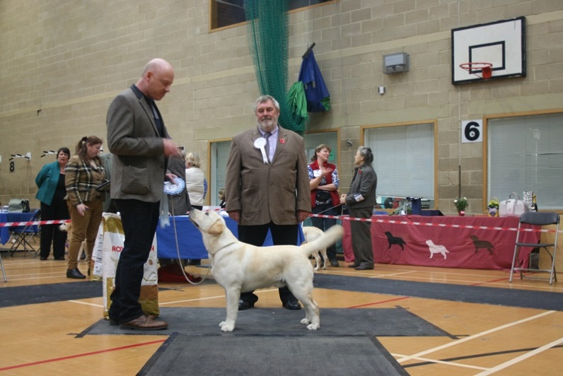Best puppy dog and best puppy in show
Mr A W & Mrs W P Glen - Millroseglen Make My Day

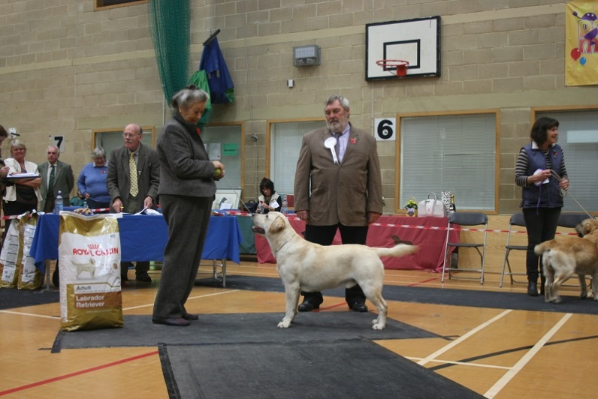Reserve best dog - Mr D Coode - Warringah's Perth JW

SPECIAL YEARLING DOG
- Finney & Callender CARPENNY SHIP TO SHORE JW
- Wyatt MEADOWLEIGH BROWN SUGAR
- Floyd TRENOW RIO GRANDE JW
- Kerry OCEANWOOD SUNSEEKER
- Wilcox DONAMICK DRUMMER BOY

MAIDEN DOG
- Glen MILLROSEGLEN MAKE MY DAY
- Van Leeuwen LINJOR CASSABLANCA
- Rawlinson CARPENNY MY PREROGATIVE AT HALISHIMOOR
- Hooper TULLOCHMOHR TARTAN EDITION AT BALCRIST
- Harvey-Major LINJOR O’GRADY
NOVICE DOG
- Parrott LOUGIN LOKI
- Glen MILLROSEGLEN MAKE MY DAY
- Van Leeuwen LINJOR CASSABLANCA
- Downey TULLOCHMOHR ZERO TO HERO
- Rawlinson CARPENNY MY PREROGATIVE AT HALISHIMOOR
UNDERGRADUATE DOG
- Dodd OAKHOUSE OPES AND DREAMS AT CARRRIEGAME
- Mills LEMBAS MIKADO
- Kerry OCEANWOOD SUNSEEKER
- Bambrook LINJOR SESSILE OAK
- White LUNAPET DAWN CHORUS
SPECIAL GRADUATE DOG (for handlers of 18 years and under)
No entries
GRADUATE DOG
- Williamson SHAROUNS LIFE OF RILEY JW
- Harvey-Major LINJOR BLACK TUXEDO JW
- Smith SMITHTRIBELAB RED RUBIN
- Lawrence DUNNABBEY HIGHLANDER
- Deane TANRONENS THEODOSIUS
POST GRADUATE DOG
- Hopkinson ROCHEBY TOAST MASTER
- Reynolds CARROMERS BLUE LAGOON
- Callender PARBUCKLE BLUE SPRUCE
- Barker DEERBROOK MILLIONHEIR
- Cary AQUADELL MONTGOMERY JW

LIMIT DOG
- Braimbridge SOUTHRIDGE SKY ROCKET TO HANNABEE
- Williamson SHAROUNS INCOGNITO JW
- Anderson & Metcalfe BARLEYBAY BRODERICK
- O’Donoghue PHILIPSTOWN BEACH BOY
- Smith SMITHTRIBELAB RED RUBIN
OPEN DOG
- Stafford SH CH FARNFIELD TOPO GIGIO (AI) JW SHCM
- Hodge CH NAIKEN ZEPHYR JW
- Hopkinson POL CH ROCHEBY MISTER TOM
- Downey TULLOCHMOHR GIBBS JW
- Rawlinson SH CH FULWELL FLY HIGH TO HALISHIMOOR
VETERAN DOG
- Miles ATTIKONAK BUTTON UP YOUR OVERCOAT AT LLANSTINAN (IMP SWE)
- Litherland OAKHOUSE OFFICE HEAD
- Bond THORNCROSS WINDWARD

STUD DOG
No entries

DOG CHALLENGE CERTIFICATE SOUTHRIDGE SKY ROCKET TO HANNABEE
DOG RESERVE CHALLENGE CERTIFICATE WARRINGAH’S PERTH JW
BEST PUPPY DOG MILLROSEGLEN MAKE MY DAY

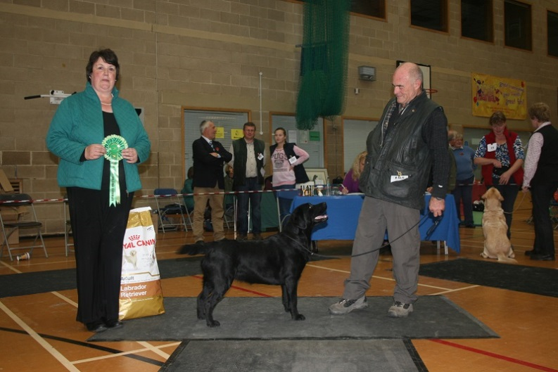Reserve best bitch Mr B F & Mrs P A Parrott - Lougin Lyin' Eyes

MINOR PUPPY BITCH
- Hopkinson KILBURNPARK MISS MAUREEN AT ROCHEBY
- Reynolds CARROMERS SHIMMERING TIARA
- Ennis-Holden KILBURNPARK MISS JANET
- Downey TULLOCHMOHR HAPPY EDITION
- Lawrence VELVETINE PREHNITE AT DUNABBEY
PUPPY BITCH
- Charlton FOXRUSH LIMITED EDITION
- Hopkinson ROCHEBY SWEET SENSATION
- Hooper TULLOCHMOHR DREAM OF ME AT BALCRIST
- Brambles SHAYMILONEY STORMIN NORMA
- Powell SEATALLAN XERONEMA
JUNIOR BITCH
- Parrot LOUGIN LAVANYA
- Wood SECRET SPY AT SUNDYKE
- Carpanini CARPENNY MY DELIGHT
- Charlton FOXRUSH SPECIAL EDITION
- Schopen BARNAGROW ALTISIDORA

BITCHES: JUDGE MRS MARGARET BROWN

SPECIAL YEARLING BITCH
- Reynolds CARROMERS HOT OFF THE PRESS JW
- Coode WARRINGAH’S GURLEY JW
- Braddon TRENDLEWOOD SILENT NIGHT JW
- Shirton WOOLMAN PROPER FANCY FREE
- Hodge NAIKEN ALIZE

MAIDEN BITCH
- Charlton FOXRUSH LIMITED EDITION
- Hopkinson ROCHEBY SENSATIONAL
- Hooper TULLOCHMOHR DREAM OF ME AT BALCRIST
- Brambles SHAYMILONEY STORMIN NORMA
- Flockton DYLSONLEIGH GEORGIE GIRL
NOVICE BITCH
- Parrot LOUGIN LYIN’ EYES
- Charlton FOXRUSH SPECIAL EDITION
- Frazer SILMARILLION LADY LUTHIEN
- Bean CELTWOOD ROSE QUARTZ
- Longhurst HURSTMELON ALIONA VILANI

UNDERGRADUATE BITCH
- Flockton DYLSONLEIGH TICKLED PINK
- Williamson ENELEON EASY DOES IT FOR SHAROUNS
- Shirton WOOLMAN PROPER WISHMAKER
- O’Brien MAXFIELD MAYBELLINE JW
- King LINTHWAITE LOUISIANA
SPECIAL GRADUATE BITCH (for handlers of 18 years and under)
- Mills TRENDLEWOOD SING AT JAYBEC
GRADUATE BITCH
- Schopen LEJIE SONG OF SUMMER
- Powell SEATALLAN WATERLILY
- Parrott LOUGIN LONA
POST GRADUATE BITCH
- Jones HAFNAU ANASTASIA
- Parrott LOUGIN LAMAZE
- Hopkinson ROCHEBY SMALL TALK
- Dodd CAMBREMER SUMMER BREEZE AT CARRIEGAME
- Phillips SHEENARON MERRY EXCUSE ME
LIMIT BITCH
- Dodd BROCKBURROW BREAKING DAWN
- Frazer LINDALL RAZZLEDAZZLE AT SILMARILLION
- Ellis & Matulla TRENOW PRIMROSE AT DOLWEN
- Shirton WOOLMAN PROPER STARLIGHT
- Harman LAKEMEADOW LOTUS BLOSSOM OF KARELDIS
OPEN BITCH
- Mills SH CH LEMBAS MAMMA MIA JW
- Coode WARRINGAH’S MERRIWAGGA JW
- Hodge CH NAIKEN XCULSIVE DREAM JW AW(B)
- Parrott SH CH NAIKEN YELENA AT LOUGIN
- Beer TARKABBY EMBRACE

VETERAN BITCH
- Rogers WOODMIST SAFFRON
- Hodge LINDALL NADIA AT NAIKEN JW
- Mills TRENDLEWOOD SING AT JAYBEC
- Burrows CARANBE ENCHANTRESS SHCM

BROOD BITCH
- Rogers WOODMIST SAFFRON

BITCH CHALLENGE CERTIFICATE BROCKBURROW BREAKING DAWN
BITCH RESERVE CHALLENGE CERTIFICATE LOUGIN LYIN’ EYES
BEST PUPPY BITCH KILBURNPARK MISS MAUREEN AT ROCHEBY
BEST IN SHOW BROCKBURROW BREAKING DAWN
RESERVE BEST IN SHOW & BEST OPPOSITE SEX SOUTHRIDGE SKY ROCKET TO HANNABEE
BEST PUPPY IN SHOW MILLROSEGLEN MAKE MY DAY
BEST VETERAN IN SHOW ATTIKONAK BUTTON UP YOUR OVERCOAT AT LLANSTINAN (IMP SWE)

